Relational (Behaviour) Policy


Approved by: | Penny Harris (Director)  Jane Cox (Director) | Date: 1st September 2024
Last reviewed on: | June 2025

Next review due by:

All policies are generated and reviewed with an awareness of equality and diversity in relation to pupils, staff and visitors. All policies are generated and reviewed placing safeguarding and wellbeing at the heart of all that we do.

- Aims
- To ensure On Track staff recognise that behaviour is a form of communication and/or unmet need
- To develop relationships with secure attachments to positively support students socially, emotionally and academically
- To be responsive to students' additional needs using their EHCPs, relational support plan, Maslow's Hierarchy of needs, and a trauma informed approach
- To understand On Track’s ethos mantra and school systems to support student’s needs whilst giving clear and consistent boundaries

- Legislation and Statutory Requirements

This policy is based on:
- The Special Educational Needs and Disability (SEND) Code of Practice, 2014 (DfE)
- Education (Independent School Standards) Regulations, 2014
- The Equality Act, 2010
- Supporting Pupils with Medical Conditions at School, 2014 (DfE)
- Searching, Screening and Confiscation, Advice for Schools, 2022 (DfE)
- Behaviour and Discipline in Schools, 2016 (DfE)
- Sexual violence and sexual harassment between children in schools and colleges, 2021 (DfE)

- Related Policies

This policy should be read alongside:
- Safeguarding and Child Protection Policy
- Incident and Information Reporting Policy
- Anti-Bullying Policy
- Suspension Policy
- Staff Code of Conduct Policy
- Staff Development Policy
- Staff Recruitment Policy

- Principles
- Our relational behaviour policy will recognise attachment theory, PACE, Trauma informed and The Thrive approach.
- Provide pupils with a sense of success and positive achievement and improvement which will support them in feeling abler to make positive choices and confidently manage their own behaviour
- Meet the emotional and educational needs of pupils
- Raise the self-esteem and confidence of pupils

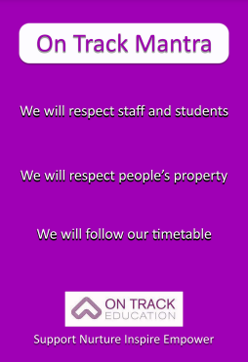

- Roles and responsibilities

The Directors:
- Responsible for monitoring this behaviour policy’s effectiveness and holding the Head Teachers to account for its implementation.

Head Teacher:
- Responsible for reviewing and approving this behaviour policy. The Head Teacher will ensure that the school environment encourages positive behaviour and that staff deal effectively with poor behaviour in the best interests of the pupil, and will monitor how staff implement this policy.

All school staff are responsible for:
- Building and maintaining positive professional relationships with all pupils
- Modelling calm and professional behaviour at all times
- Treating pupils with tolerance and respect
- Managing pupils in relation to their individual differences and behaviour support plans
- Referring to the On Track Mantra
- Recording all behaviours and reporting on our MIS
- Inform SLT of escalating behaviours that pose a risk to others
- Editing the behaviour support plans accordingly

All school staff follow a comprehensive induction programme to ensure they have read, understand and will implement all relevant school policies including this policy, the Staff Code of Conduct and those relating to Safeguarding and Child Protection.

Key teams are responsible for:
- Supporting pupils to regularly reflect on their behaviour
- Liaising with home when necessary
- Monitoring behaviour concerns and requesting a TAC meeting if appropriate
- Completing chronologies
- Praise pupils for going over and above and complete success forms
- Ensure that lessons are prepared and engaging to limit disruptive behaviour from pupils

Senior Leadership are responsible for:
- Being a visible presence around the school
- Holding teachers to account for following the behaviour policy
- Regularly sharing good practice
- Use data to target and assess where behaviour changes need to take place
- Regularly review provision for learners who are regularly flagged with behaviour concerns
- Support staff to ensure consistent practice across the school

- Individual Behaviour Support Planning

Each pupil has a Behavioural Risk Assessment which is begun before they start at the school to include information from previous school/s and professionals. This individual behavioural risk assessment is edited as their time goes on to include any new findings and observations.

The Relational Support Plan is then written to address issues raised in the Behavioural Risk Assessment and directly informs the relational support plans to include:
- The pupil’s positive characteristics, strengths and interests
- The pupil’s specific behaviours that are planned for
- Triggers that are known to bring about behaviours
- Warning clues
- Early interventions
- Active interventions
- Specific planning issues
- Interventions which should be avoided
- How the pupil can help his/herself to reduce difficulty/risk
- How success will be measured
- Key staff to be involved
- Further staff training required

This plan, and the proactive and reactive strategies, are reviewed regularly, in light of incidents of difficult behaviour and of successes. Staff apply a level of flexibility in accordance with the needs of the pupil, and their own dynamic with the pupil, on any given day. Staff recognise that a reduction in the frequency or intensity of poor behaviour is improvement and progress for an individual pupil.

- Positive relational Management Strategies

Meeting the need of the students:

We know how important it is for our students to be ready to learn and they need their basic needs met first. We offer breakfast and lunch to all of our students to meet “physiological needs”, we ensure a safe environment and that students feel that they belong to the On Track community with students working with key staff and supporting their “psychological need” and building relationships. (Maslow 1943). Appendix 3

To support students who are struggling to engage with the On Track mantra we have off site + to support students in building relationships with staff. This is based on a 3 week program to build positive relationships and interaction and be more ready to learn on sites.

THRIVE and Zones of regulation:

The Thrive Approach draws on insights in attachment theory, child development and neuroscience to provide a way of working with children and young people that supports optimal social and emotional development and helps them re-engage with life and learning. We base our emotional development planning and delivery on the Thrive programme. Each pupil has a Thrive assessment completed each term which provides targets for emotional development. This feeds into Thrive programme planning, lesson delivery and intervention work for each pupil.


The Zones of Regulation framework. The Zones approach is a systematic, cognitive-behavioural approach used to teach us how to regulate our feelings, energy and sensory needs in order to meet the demands of the situation around us and be successful socially.

Trauma Informed approach

We understand that children need emotional connection with adults and children where they feel safe, cared for and known. Traumatised children can often end up behaving in ways that are actually familiar to them, where their subconscious is replicating the early and frightening relational experiences they had. (Betsy de Thiery, 2017)

Key staff are aware of any Adverse Childhood experiences that their students may have had and can put in protective factors.

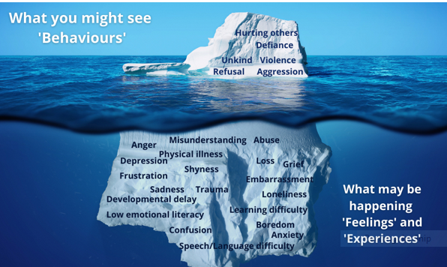

Regulation

To help our students to regulate we use VRF’s (Thrive vital relational Functions)

Attune- Match the child’s energy using your body, face and voice. “Oh wow! I can see your face is red and your fists are clenched.”

Validate- Let the child know its ok to have the feeling. “I’m wondering if/ imagining that/ noticing that you might be feeling sad/ cross/ frightened/ excited. If that had happened to me, I would feel that way too”

Contain- be alongside as a helpful, supportive adult

“I can see this is tricky for you and I will keep you safe.” Break things down into manageable chunks. E.g., “First, we will…..”

Regulate – soothe or stimulate the child back to social engagement

“Let’s breathe together until you feel calmer.”

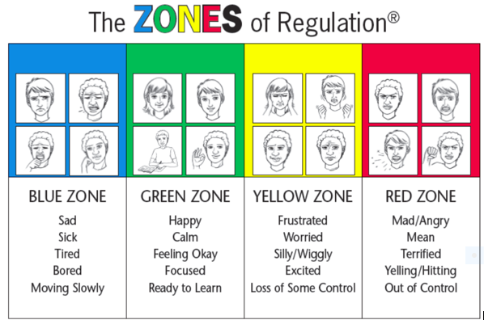

“I’ve learned that people will forget what you said, people will forget what you did, but people will never forget how you made them feel”

(Maya Angelou, 2015)

We encourage our staff to adopt the PACE approach and monitor through zones of regulation. PACE stands for Playfulness, Acceptance, Curiosity and Empathy. It was developed by Dan Hughes more than 20 years ago as a central part of attachment- focused family therapy, with the aim of supporting adults to build safe, trusting and meaningful relationships with children and young people who have experienced trauma. Play is crucial for relationship building and repeated positive play experiences help build connections in the brain. Appendix 1.

Use of sensory breaks

If a pupil wishes to remain in the building and find a safe space to calm down, under staff supervision. If a pupil requires time away from a situation or away from the school site, staff will take that pupil to a safe place outside the building, and maybe a distance away from the building to give them the space and change of scene required to calm. Some students need time on their own and will be offered a ten-minute walk around the block, this has to have parent permission and be risk assessed.

Parental / Carer Support and Contact

We seek the support of families to work as a team to help our pupils to improve their ability to self-regulate and make safe choices. The Head Teacher and school staff prioritise maintaining regular contact with parents/carers, keeping them fully informed and involved in the pupil’s education and time at school. We offer family Thrive interventions and have a home liaison officer who supports families.

Multi-agency support and Contact

The school will work with a variety of outside agencies to support pupils to address issues which are impacting on their behaviour. If there begins to be difficulties surrounding a pupil’s behaviour where there were no difficulties before, or the levels of inappropriate behaviour have significantly increased, a multi-agency meeting will be arranged. The meeting will involve all professionals working with the pupil and will aim to find new strategies and ways forward to more effectively support the pupil. An Early Help Assessment may be considered to support the pupil and, potentially, their family.

8. Overcoming Barriers

Smoking/ Vaping and mobile phones:

On arrival to school, Staff will ask students to place phones/vapes/smoking paraphernalia into student lockers and give time for students to follow the expectation. Offsite learners are to use lock boxes or clear boxes whilst offsite. This request to put/lock away or to not be in the staff sight is repeated if initially refused.
Students have their own keys for lockers, they use boxes for offsite days when with staff.

If the student chooses not to do this, then the following day will be an offsite day to support the young person in the process. Lock boxes are to be used in cars, as managed by daily staffing by site for learners. If the refusal continues for 2 days, a fixed term exclusion is issued.

Students in Key stage 4 upwards will be given independence/walk time (where appropriate) to an agreed location for a strict 10 minutes at break and lunchtime each day, this will be added to their RA and parent permission will be required. They will still be expected to follow school policies when off site.

Phones and vapes etc. can be handed in or must not be seen by staff if kept on a student's person. After monitoring and supporting for 1 week, if a student is struggling to follow the policy successfully, they will move to an offsite + provision to then create a bespoke plan and a relationship with staff to support success in following the policy.

Post-16 Students will be allowed to keep phones and vapes/smoking paraphernalia on them but they must not be seen during the school day. They may also choose to use a locker but phones will be permitted during lunch time in their rooms.

Absconding

If a pupil absconds from the school or a staff member, the pupil will be followed at a distance which does not provoke the pupil to run (putting themselves in a less safe situation) but which enables the staff member to retain sight of the pupil at all times. If the student is out of sight for more than 10 minutes’ staff member to contact SLT. If no sight for 10 minutes, contact students home and make parents/ guardians aware. Parents/ Guardians to be asked to make contact with student if possible and to phone school back. If student is missing for more than 20 minutes’ parents to be made aware and ask if parents would like to take parental responsibility or whether police should be called to report as missing.

Anti-Bullying Policy
Our school is committed to creating a safe and inclusive environment where all students feel respected and supported. Bullying, in any form, is not tolerated. Students involved in three incidents of child-on-child bullying within the same week will trigger a one-day off-site intervention focused on understanding and improving their behavior. If a student requires a second anti-bullying intervention within the same half-term, they will have another day off-site, and their parents or carers will be invited to school for a formal meeting to discuss the concerns and develop a collaborative plan to support positive behavior. This approach emphasizes accountability, education, and partnership to address bullying effectively and foster a culture of respect.

- Post incident Support

We recognise that, following a behavioural incident, pupils and staff may need time and space to be able to be calm and reflective. An appropriate staff member, or Head Teacher, will discuss the incident with the pupil at a time when the pupil has calmed sufficiently to ensure that the discussion itself does not create a situation of re-escalation. School staff are aware that other pupils may witness incidents that cause them to be upset and they will also be offered support. During post incident support the voice of the pupil will be listened to in order to inform understanding and outcomes.

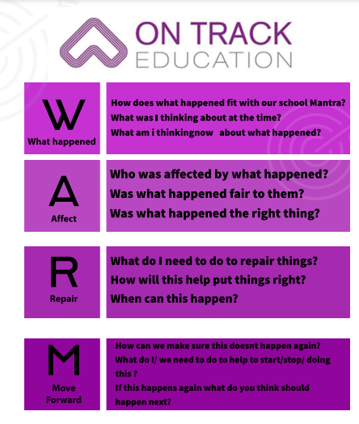

- Behaviour Tracking

The behavioural progress for each pupil will be tracked to provide a measure for current behaviour and to allow evaluation of interventions, monitoring of improvement, as well as enabling staff to develop effective and consistent interventions. Robust measures are in place to track, record and monitor behaviour utilising Chronologies and the school MIS. This supports us in making decisions for student of the week. All students have the opportunity for a relational day with key staff on three occasions throughout the year.

- Finding the positives

This school prioritises rewarding positive behaviour as opposed to sanctioning poor behaviour. Consequences for poor or inappropriate behaviour will be personalised for each student but may include:
- Restorative action
- Tutor meeting
- Meeting with the Head Teacher
- Invoices for damage to property
- Temporary change to timetable/ offsite plus
- Phone call/meeting with parents/carers and other professionals
- Exclusion (see separate school policy)

Our school staff will make sparing and consistent use of reprimands, in a non-aggressive and advisory tone, addressing behaviour and not the person. Our staff will use private, rather than public reprimands whenever possible.

- Restrictive Physical Intervention

School staff are all trained in Safety Intervention ensuring that we operate within the principles of BILD and according to DfE guidance.

In extreme circumstances, and where there is no other choice, restrictive physical interventions may be used by trained staff members, as follows:
- Restrictive physical intervention should be an absolute last resort
- Restrictive physical intervention will only be used when necessary and to keep people safe
- The least restrictive form of physical intervention will always be used and used for the shortest time possible for staff to gain control of the situation and eliminate the immediate risk of injury.
- All incidents involving restrictive physical intervention will be recorded and logged
- Post-incident support will be offered to the pupil and staff members involved in restrictive physical interventions
- Parents/carers will always be informed when a restrictive physical intervention has taken place
- Where relevant, social workers, Youth Offending Team or other involved professionals will be informed
- Each pupil’s Relational Support Plan should be reviewed and updated if necessary following the use of restrictive intervention
- Under no circumstances should a pupil be struck or handled. Corporal punishment is illegal in all circumstances.

- Searches
Safeguarding and the best interests of the child should be the primary consideration in relation to searching a pupil. There must be a balance between:
- The need to safeguard all pupils by confiscating harmful, illegal, or disruptive items
- The safeguarding needs and wellbeing of pupils suspected of possessing these items

Keeping Children Safe in Education (KCSIE) sets out the statutory duty of all staff to make sure that they make decisions in the best interests of the child. This applies to decisions to search pupils and confiscate items. There should be vigilance about possible biases affecting the decision to search a pupil and consideration that all pupils have a right to expect a reasonable level of personal privacy, under Article 8 of the European Convention on Human Rights. Any 'interference' with this right by our school must be justified and proportionate.
A pupil will only be searched if there is a good reason to, considering that it could infringe upon their wellbeing and rights in several different ways. For example:
- Loss of privacy when clothes, bags or possessions are searched
- Loss of a sense of security, if they feel they are being monitored and searched without reason
- Impact on a pupil’s dignity or reputation if they are searched or suspected of possessing prohibited items

Confiscation of items should be treated as a safeguarding issue. Children in possession of drugs, alcohol or weapons should be considered vulnerable and at risk of exploitation. Paragraph 20 of KCSIE highlights the need to be alert to the potential risks of children who are:
- Showing signs of being drawn in to anti-social or criminal behaviour
- In challenging family circumstances, such as drug and alcohol misuse
- Misusing drugs or alcohol themselves
- Children in possession of drugs, alcohol or weapons should be considered vulnerable

A search can play a vital role in identifying pupils who may benefit from early help or a referral to the local authority children’s social care services. The designated safeguarding lead (DSL) should make an immediate referral if they find evidence that a child is at risk of harm.
Who can carry out a search and when
Only the head teacher, and members of staff authorised by the head teacher, have the power to search a pupil for a prohibited or banned item. They can do this if:
- The pupil agrees to the search, or
- The authorised staff member has 'reasonable grounds' to suspect that the pupil may have a prohibited or banned item (see the next section for definitions of these)

Under law:
- The person carrying out the search must be the same sex as the pupil being searched
- There must be another member of staff present as a witness to the search

The only exception to this is if:
- The searcher reasonably believes that there is a risk of serious harm being caused to a person if a search isn’t carried out urgently and
- It's not reasonably practical to summon another member of staff (to carry out the search or act as a witness) within the time available

When an authorised staff member conducts a search without a witness, they should immediately report it to another member of staff, and make sure that a record is kept.
The member of staff witnessing the search must also be the same sex as the pupil being searched if this is reasonably practicable (paragraph 6(d) of section 550ZB of the Education Act 1996).
What you can search for
SLT and authorised staff members can search a pupil for:
- Any items with the pupil's informed consent
- Prohibited or banned items, with or without the pupil's consent

Prohibited items are:
- Knives or weapons
- Alcohol
- Illegal drugs
- Stolen items
- Tobacco and cigarette papers
- Fireworks
- Pornographic images

Any article that the member of staff reasonably suspects has been, or is likely to be, used to:
- Commit an offence
- Cause personal injury (including the pupil) or damage to property

How to carry out a search
The SLT or authorised staff member should:
- Make an assessment of how urgent the search is, and consider the risk to other pupils and staff
- Explain to the pupil why they are being searched, how and where the search will happen, and give them the opportunity to ask questions about it
- Always seek the pupil's cooperation

If a pupil refuses to cooperate, the authorised member of staff should first consider why this is, and act proportionally. It may be that the pupil:
- Is in possession of a prohibited or banned item
- Doesn’t understand your instructions or what a search will involve
- Has had a previous distressing experience of being searched

If the pupil still refuses to cooperate, and there is not evidence that a search is needed urgently, the pupil should be supervised somewhere away from other pupils. The head teacher should assess whether it's necessary to use reasonable force to conduct the search. This should only be considered if this would prevent the pupil from harming themselves or others.
The pupil should only be searched in an appropriate location that offers privacy from other pupils.
Authorised staff can search a pupil’s pockets and require pupils to remove outer clothing, meaning clothes that are not worn directly next to the skin or over underwear. Outer clothing also includes:
- Hats
- Scarves
- Shoes or boots

Pupils cannot be asked to take off any further items of clothing.
Authorised staff can search bags in the presence of the pupil and another member of staff (except in cases where there's a risk of harm and where it's not reasonably practicable to summon another member of staff - see section above on who can conduct a search for more detail). A metal detector may be used.
School staff are not allowed to carry out strip searches, including the head teacher and authorised staff. Only police who have been asked to come to the school may decide whether a search is necessary and carry it out. The police can only carry out a search if they:
- Think this is necessary to remove an item related to a criminal offence, and
- Reasonably consider the pupil might have concealed such an item

The police should be called into school as a last resort and the best interest of the child should be considered first. Before the police are called:
- Ensure all other approaches have been exhausted
- Carefully weigh up the risks to the pupil’s mental and physical wellbeing with the need to conduct a search

Where reasonably possible, parents should be informed that a strip search will happen (and should always be informed after it has been carried out)
There must be an 'appropriate adult' is present during the police search. This is a person whose role is to safeguard the rights and welfare of children who are suspected of a criminal offence, by ensuring they are treated fairly and are able to participate effectively.
The police officers conducting a strip search must be the same sex as the pupil. There must be at least two people present other than the pupil, including the 'appropriate adult'. The search may only take place without an appropriate adult if:
- It is an urgent case where there is risk of serious harm to the pupil or others, or
- The pupil explicitly states that they don’t want an appropriate adult present for the search, and the appropriate adult agrees and signs a record of the pupil’s decision

The appropriate adult should be the same sex as the pupil, unless they specifically request someone else. The role of the appropriate adult is to advocate for pupils' wellbeing at all times. A strip search can be highly distressing for the pupil, and for staff and other pupils affected.
The police cannot overrule this safeguarding duty, for example by requesting that the appropriate adult leave the room when they talk to the pupil.
Always put safeguarding at the centre when supporting the pupil, regardless of whether a prohibited item is found. The pupil should have an opportunity to express their views regarding the search.
If a prohibited item is found:
- Consider it a safeguarding matter as well as a police matter
- Involve relevant staff and treat the pupil as potentially vulnerable

If a prohibited item is not found:
- Take a safeguarding approach to supporting the pupil to cope with the experience of being searched
- Consider the wider issues that may have informed the decision to request a search in the first place
How to record searches
A record should be made on MIS of:
- Any searches for prohibited items
- Any search conducted by police officers
- Record these whether or not any items were found.

The head teacher should look for any trends in the searches carried out and identify any possible risks that may require a safeguarding response.
What you can confiscate
Authorised staff members can confiscate any item they find that they have reasonable grounds for suspecting:
- Poses a risk to staff or pupils
- Is a prohibited or banned item
- Is evidence in relation to an offence

Authorised staff members will need to do different things with confiscated items, depending on what they are:
Controlled drugs, or substances you suspect are controlled drugs or could be harmful | Deliver to the police (or safely dispose of if there is a good reason to do so)
Alcohol | Retain or dispose of as appropriate
Tobacco or cigarette papers | Retain or dispose of as appropriate
Fireworks | Retain or dispose of as appropriate
Stolen items | Deliver to the police, or return to the owner or dispose of (see the advice on page 18 of the DfE guidance)
Weapons or items which are evidence of a suspected offence | Deliver to the police as soon as possible
Items that have been (or are likely to be) used to commit an offence or cause injury or property damage | Deliver to the police return to the owner, retain or dispose of (see the advice on pages 18 and 19 of the DfE guidance)
Pornographic material | Dispose of (see the section below for guidance)
Pornographic material that you suspect constitutes a specific offence (i.e. it is extreme or an indecent image of a child) | Deliver to the police as soon as possible

Searching and confiscating electronic devices
Authorised staff members may examine any data or files on an electronic device that they have confiscated, if they have good reason to do so; grounds for reasonable suspicion that the device has (or could be used to):
- Cause harm
- Undermine the safe environment of the school or disrupt teaching
- Commit an offence

If inappropriate images, video, or other material, are discovered, they may be disposed of (see page 20 of the DfE's guidance for advice).
If there are reasonable grounds to suspect that their possession is related to a specific illegal offense, the material must not be destroyed. Instead, the material, or device containing the material, should be handed over to the police as soon as possible.
If there is a suspicion that an indecent image or video of a child is on a device, avoid viewing it and never copy, share, or save it; the DfE's guidance on responding to pornographic image-sharing in education settings should be followed.

- Review

In order to ensure that this policy is relevant, if you have any suggestions for additions or amendments please email directors@ontrackeducation.com

Appendix 1: Dan Hughes’ PACE Approach

PACE refers to Playfulness, Acceptance, Curiosity and Empathy: Playfulness involves spontaneity, openness and exploration; have fun and share enjoyment with the pupil. Using playfulness can defuse tense situations and is useful to manage minor behaviours, as the pupil is less likely to respond with anger or defensiveness. Acceptance involves unconditional positive regard for the pupil. Accept the pupil’s inner experience without judgement and make sense of why the pupil is behaving in a certain way. Acceptance does not mean accepting negative behaviours, but accepting the reasons behind behaviour. When necessary, criticize the behaviour, but not the pupil. Curiosity involves wondering about the reasons behind the behaviours, rather than being angry. This shows the pupil that you care and helps them make sense of their behaviour, feelings and experiences. Use phrases like “I wonder if you are feeling like this because…” to open up discussions with the pupil.

Empathy involves showing them that you understand how difficult they are finding things and reassuring them that you want to help them to manage this. Validate the pupil’s emotional experience with phrases such as “I know how difficult that must have been for you” and work together to find ways to support them. For more information about the PACE approach please refer to literature by Dan Hughes.

Real examples of PACE in action: Pupil in heightened state of anxiety, attempting to climb fence and not following instructions to come down. Application of PACE: Playfulness – Use playful language to de-escalate the situation. "Goodness me I really would rather you came down. Problem is that if you fall I will have to fill out a lot of forms and I'm a bit like you - I don't really like writing." Acceptance - the pupil is experiencing extreme anxiety as a result of a fall out with a friend and that this is a real experience. Communicate that you accept how they feel (e.g. “I can see that this has made you feel really upset”). Avoiding saying things like, "Oh it doesn't matter, don't be upset about a silly fall out." Curiosity- Enquire and check what the young person's emotional experience is. "I wonder if you're feeling angry because of what X just said?" Empathy - Show that you understand that how difficult they are finding things. "I understand that this must be really difficult for you. I know that when I am feeling upset I just want to run away from everything." Using PACE and a calm approach, the pupil's anxiety decreased and they came down off the fence. They went with an adult to the sensory room. Instead of imposing consequences, once the pupil was calm, a discussion was had about the dangers of climbing the fence. The pupil was able to reflect on their behaviour and think of alternative things they could do next time (e.g. go to the sensory room)

Appendix 2: ACEs

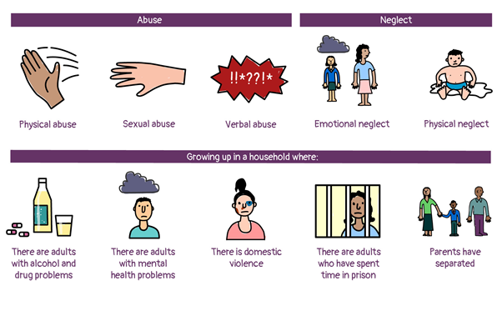

Appendix 3: Maslow's Hierarchy of need (1943)
